Abstract

From the knowledge of four months of training from SURE TRUST in robotics I worked on a project where I designed a drone which can be used in surveying and mapping.

ROBOTICS

Final project , SURE TRUST

DRONES

For surveying and mapping

# INTRODUCTION

* According to 2015 statistics from the US Department of Labor, there are 44,300 surveyors in the United States.
* The American Society of Civil Engineers lists more than 150,000 members in 177 countries, and the Imaging and Geospatial Society has 7,000 supporters.
* All of these disciplines can be grouped under a broader category called geographic information systems (GIS).

# USE CASES

* Automated mapping
* Cadastral surveying
* Corridor surveying
* Volumetric calculations
* LiDAR mapping

# Automated Mapping

* 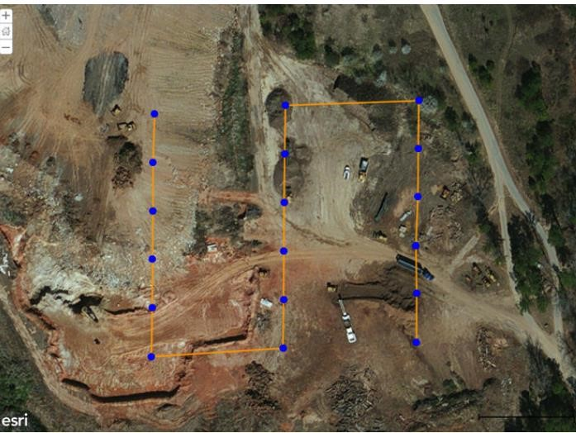Workflow for automated mapping applications begins by establishing control points.
* Once control points are in place, the drone’s flight path is calculated by using a mission planning application.
* This solution enables the drone to fly autonomously at a set altitude while taking pictures at two or three-second intervals.

# Cadastral Surveying

* 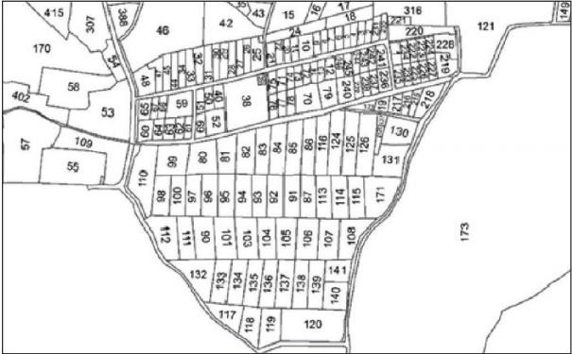Cadastral surveying establishes property boundaries consisting of land and buildings on a parcel.
* It can describe:

⮚The size and extent of the property being bought or sold.

⮚The location of buildings, fences, and driveways

## Corridor Surveying

* 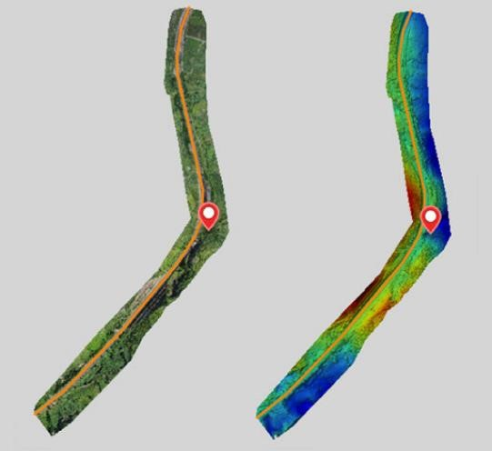Drones are uniquely suited for mapping road, highway, and railway infrastructures because they are extremely cost effective compared with collecting data via manned aircraft, satellites, or road crews.
* Simple image capture can render photomosaic images of pavement or rail conditions, lane marking, vegetation encroachments, and general road conditions as well as provide planners a digital surface model.
* It allows mapping and surveying professionals to capture minute LiDAR Mapping details that photos can’t and with those details create precise digital representation of objects, buildings, and the ground.
* LiDAR is based on same concept of RADAR instead of radio waves they use laser.
* By sending out laser beams in all directions, collecting the reflected energy, and performing some nifty high-speed computer processing, a scanner can create a real-time, virtual map of the surrounding area.

Robotics

As a application of drones

* Robotics is a multidisciplinary field that combines aspects of engineering, computer science, and other scientific disciplines to design, construct, operate, and use robots.
* Robots are automated machines capable of performing tasks autonomously or semi-autonomously, often with the goal of improving efficiency, precision, and safety in various applications.
* Components of Robotics:
* Mechanical Design: Involves creating the physical structure of the robot
* **Electronics**: Includes the circuitry, sensors, and actuators that enable the robot to interact with its environment.
* **Programming**: Involves creating the software that controls the robot's behavior and responses.
* **Types of Robots**:
* **Manufacturing**: Automation in factories to enhance efficiency and precision.
* **Healthcare**: Surgical robots, robotic prosthetics, and telepresence robots for patient care.
* **Exploration**: Use of robots in space exploration and deep-sea exploration.
* **Military and Defense**: Unmanned aerial vehicles (UAVs), bomb disposal robots, and surveillance robots.
* **Challenges in Robotics**:
* **Sensory Perception**: Developing robots that can accurately perceive and interpret their surroundings.
* **Human-Robot Interaction**: Ensuring safe and effective collaboration between humans and robots.
* Robotics has the potential to revolutionize various industries and improve the quality of life by automating repetitive tasks, enhancing precision, and addressing challenges that may be hazardous or difficult for humans.
* As technology continues to advance, the field of robotics is expected to see continuous growth and innovation.

DRONES

* Drones, also known as Unmanned Aerial Vehicles (UAVs) or

Unmanned Aircraft Systems (UAS), have become increasingly popular for surveying and mapping applications due to their versatility, costeffectiveness, and efficiency.

**Aerial Imaging**:

* Drones are equipped with high-resolution cameras and sensors that capture aerial imagery.
* Aerial photography and photogrammetry are used to create detailed and accurate maps.

DRONES

**Topographic Mapping**:

* Drones can be employed to create topographic maps by capturing detailed elevation data.
* This is particularly useful in construction, urban planning, and environmental monitoring.

**LiDAR Technology**:

* Some advanced drones are equipped with Light Detection and Ranging (LiDAR) sensors.
* LiDAR technology allows for 3D mapping, enabling the creation of detailed terrain models, even in challenging environments

PROJECT

• This drone is designed by using solid edge This basic drone for surveying consists of

1. Frame
2. Propellers iii. Motors iv. Remote control v. Batteries vi. Camera

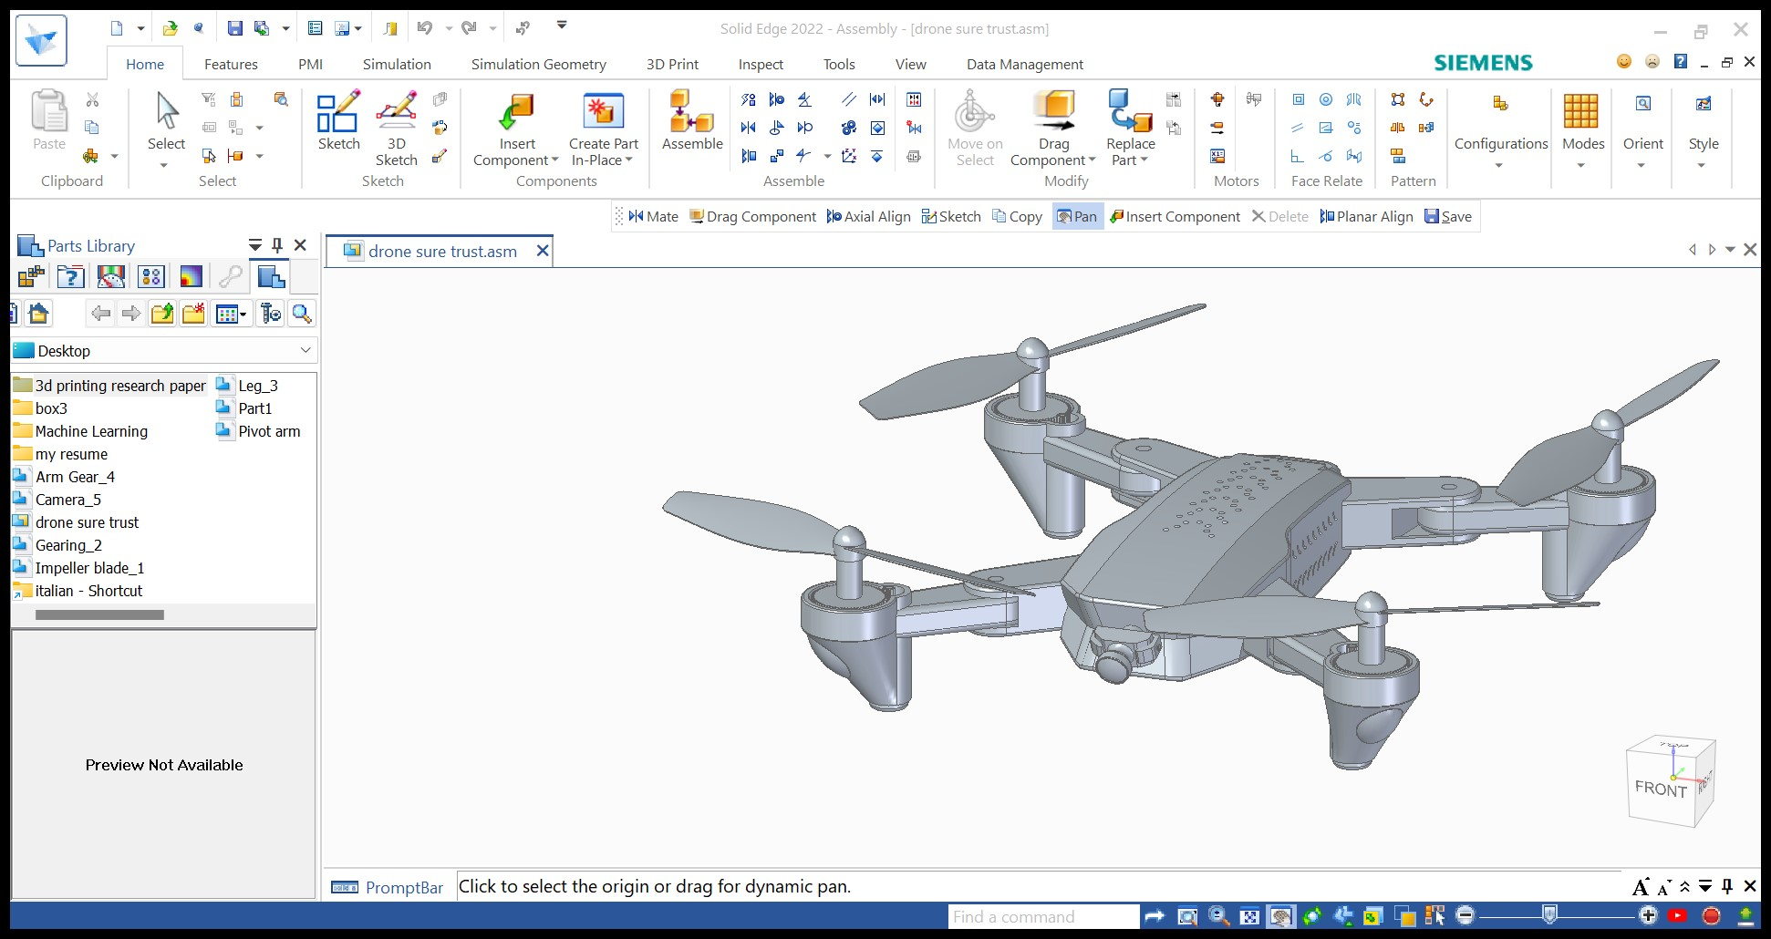DESIGN

Functions of components

**Frame and Structure**:

* The frame provides the structural foundation for the drone, supporting the payload and housing the electronic components.
* Lightweight materials like carbon fiber are often used to maximize flight efficiency.

**Propulsion System**:

* Motors and propellers generate the thrust needed for flight.
* Quadcopters (four rotors), hexacopters (six rotors), and octocopters (eight rotors) are common configurations.

Functions of components

**Remote Control or Ground Control Station**:

* Pilots use remote controls or ground control stations to operate the drone manually.
* Automated flight planning software is often used for surveying missions.

**Camera:**

* High-resolution cameras are crucial for capturing detailed imagery.
* Some drones have gimbals for stabilized camera mounting, ensuring clear and sharp images.

Functions of components

**Payload**:

* The payload includes the sensors and equipment needed for surveying and mapping applications.
* Key components may include cameras, LiDAR sensors, multispectral sensors, or thermal cam